📄 Cloud Cost Analysis & Optimization

1. Project Overview
This project focuses on analyzing cloud server cost data to identify cost inefficiencies, idle resources, and optimization opportunities. The goal is to convert raw cloud usage data into meaningful insights that help reduce unnecessary cloud expenses.

2. Dataset Summary
- The dataset includes:
  - Server ID
  - Region
  - Instance Type
  - CPU Usage
  - Memory Usage
  - Hours Running
  - Cost per Hour
Issues in dataset:
- Missing values
- Inconsistent formats
- Unstructured data
- Need for derived metrics (cost, status)

3. Data Cleaning & Structuring (Excel)
- Handled missing values
- Standardized data formats
- Structured dataset for analysis
- Ensured consistency across columns

4. Data Analysis using Python (Google Colab)
- Loaded dataset using Pandas
- Created new features:
  - Daily Cost = Hours Running × Cost per Hour
  - Status = Idle / Active (based on CPU & Memory usage)
- Applied basic Machine Learning:
  - Used Linear Regression to predict CPU usage
- Generated recommendations:
  - Idle servers → “Shutdown” (cost saving)
  - Active servers → “Keep Running”
- Calculated total potential savings from idle servers
- Performed sorting and indexing for structured output
- Created basic visualizations using Matplotlib:
  - Cost distribution
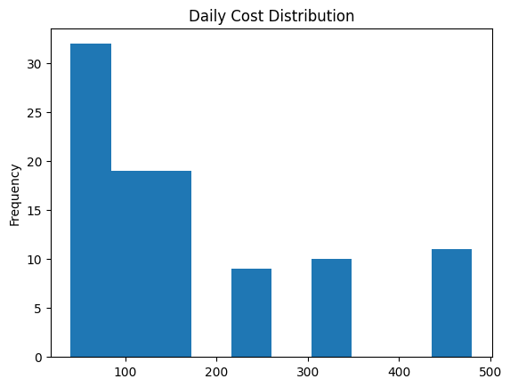
  - Idle vs Active servers
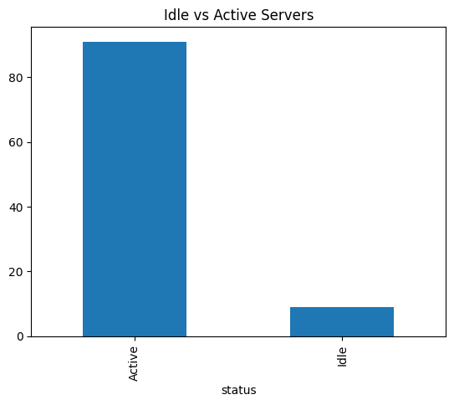
  - CPU usage vs hours running
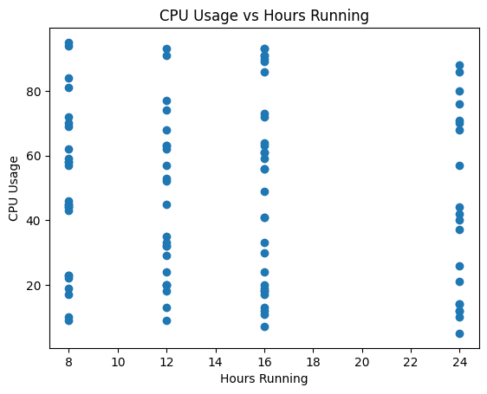

5. Data Analysis using SQL
- Queried total cost across servers
- Identified idle servers generating unnecessary cost
- Calculated potential savings
- Compared cost across regions and instance types

6. Dashboard in Power BI
An interactive dashboard was created to visualize insights.
Includes:
- KPI Cards
  - Total Cost
  - Potential Savings
  - Idle Servers Count
- Charts
  - Cost by Region
  - Cost by Instance Type
  - Idle vs Active Servers
  - Savings Opportunities
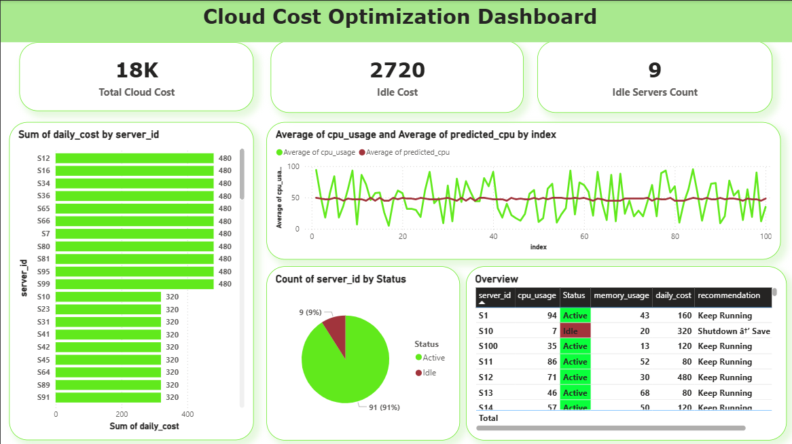

7. Key Insights
- A significant portion of cost comes from idle servers
- Certain regions contribute more to cloud expenses
- Identifying idle resources can reduce costs effectively
- Optimization strategies can lead to major savings

8. Real-World Application
- Helps companies reduce unnecessary cloud spending
- Identifies underutilized resources
- Supports better cloud cost management
- Enables data-driven decision making

9. Conclusion
This project demonstrates how cloud cost data can be cleaned, analyzed, and visualized to identify inefficiencies and optimize spending. By combining Excel, Python, SQL, and Power BI, it provides a complete end-to-end cloud cost optimization solution.

